
School Uniform

SCHOOL UNIFORMS

Gascoyne Junction Remote Community School has a dress code

The dress code requires students to wear
- School T-Shirt or Polo
- Black Shorts
- BlackTracksuit pants
- Fleece Zip Jacket
- Enclosed footwear
- Hair tied up
School uniforms are available all year round through the school office at reasonable prices.

Polo Shirts | $23.00
Shorts | $6.00
Tracksuit pants | $8.00
Tracksuit top | $27.00
Hats | $10.00

Please fill out the order form on the back and return with money to the school office.

Thank you for your support

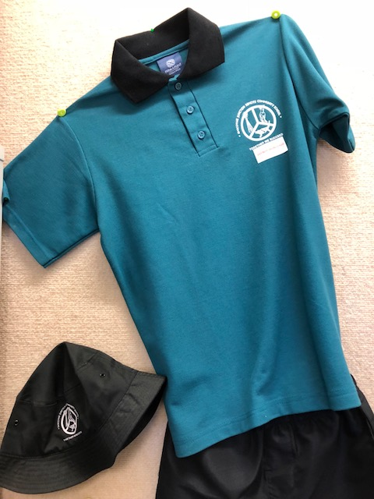
UNIFORM ORDER FORM

Family Name: ………………………….

…………………………………………..

POLO SHIRTS $23.00
Size Polo shirt | 2 | 4 | 6 | 8 | 10 | 12 | 14 | 16
Number Needed

SHORTS $6.00

Size Shorts | 2 | 4 | 6 | 8 | 10 | 12 | 14 | 16
Number Needed

JUMPERS $27.00

Size Jumpers | 2 | 4 | 6 | 8 | 10 | 12 | 14 | 16
Number Needed

TRACKSUIT PANTS $8.00

Size Tracksuit Pants | 2 | 4 | 6 | 8 | 10 | 12 | 14 | 16
Number Needed

HATS $10.00
Hats | XS | S | M | L
Number Needed

