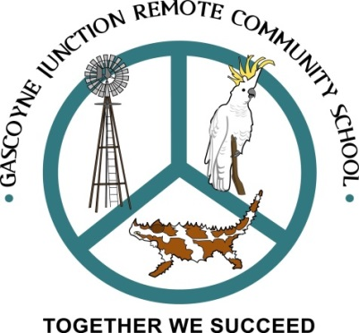
Gascoyne Junction Remote Community School
36 Gregory St GASCOTNE JUNCTION 6705
E: Gascoynejunction.RCS@education.wa.edu.au
Ph 99430515
Gascoyne Junction
Remote Community School
School Improvement Plan
2020-2022

Making a difference in a unique context:
Where your children are front and centre of all we do and where staff are passionate about your child’s education because they love what they do.
TOGETHER WE SUCCEED

Acknowledgement of country
We respectfully acknowledge the past and present traditional custodians of this land, the Yingardda people. It is a privilege to be standing, working and living on Yingardda country. We respectfully acknowledge the contributions of Aboriginal Australians and non-Aboriginal Australians to the education of all children and people in this country we all live in and share together – Australia.”

Gascoyne Junction Remote Community School is situated in the town of Gascoyne Junction where the Lyons and Gascoyne Rivers meet.
It is on Yingarrda Country, a place of vast open plains, wide skies and bright stars that our unique school sits.
Our context
Gascoyne Junction Remote Community School is situated 178 kilometres east of Carnarvon. The school services students living in the township of Gascoyne Junction, Woodgimia Community and surrounding pastoralist stations.
Employment within the community derives from The Shire Council, pastoralist stations, The Junction Pub and Tourist Park and the School. In some cases, single people are the dominant employee group. However, the Shire encourages families to apply for jobs. The Junction Pub and Tourist Park encourages families to apply.
The number of classes running at Gascoyne Junction School is dependent upon the student cohort. This can alter significantly from term to term and from year to year and as a result requires a plan that ensures routine and consistency for the stable cohort of students.
At the commencement of 2020, two classes catering for students from year one to year nine was established. There were five students in the school at the time of census who were supervised by two teachers, one Aboriginal Islander Education Officer, an Education Assistant and supported by the Principal as required. During the course of the year, extra students arrived and numbers more than doubled.
This situation occurs regularly in our school. Nevertheless, this is what makes the school unique and interesting. The change and variety of clientele provides real life situations where students practice life skills such as resilience, responsibility and respect. Furthermore, this is done within an environment where students feel safe. In this way they can safely practice important skills for social interaction across different cultures, ability groups and social groups that they may not experience in other educational contexts.
Staff commit to excellence, ongoing self-assessment and improvement to deliver high quality evidence based programmes.
The school’s focus on mathematics proficiencies through the Back To Front Maths Programme ensures students are taught from where they’re at and misconceptions are challenged. This
A safe and stimulating learning environment for all students and staff is provided. We encourage honest and open communication with parents, carers and community members to provide the best possible learning experiences for their children.

Our school
Children are front and centre
of every decision made at our little school in the bush. We understand that students may, in time, attend a larger school and need the skills and knowledge to succeed whenever and wherever they attend school. To this end, staff at Gascoyne Junction school acknowledge parents, families and communities as the first educators of their children and work with them to ensure solid evidence based programmes are delivered to students. At our school, teachers are well versed in moderation activities to ensure true and valid judgements are given for each and every student.
Before we make a decision about our students we ensure we know the whole child, then our questions begin. What is best for this learner? What evidence suggests that a particular programme would benefit this student? What can I develop with what I know? What could I do differently to improve this outcome? What was successful and why?
Furthermore, as part of our continuous self- assessment plan for school improvement, we ask, “How are we going? How do we know? What can we do to improve?” These questions ensure we rigorously examine and modify our practice regularly to ensure success for all students.

Self-Assessment

Vision
Working together in a unique and inclusive community to provide a safe and committed
learning environment where students are guided to be resilient, courageous leaders
with the confidence to reach their full potential.

Mission To focus on helping every student find success in a way that is meaningful to them.

Motto Together we succeed

Values Respect, Resilience and Responsibility

Philosophy
We ensure you will see
- positive teacher, parent-student relationships, high expectations and high quality teaching
- active, open communication and feedback with and from staff, students, parents and community, because it is essential to further support student engagement and progress.
- safe and inclusive learning environment for every child regardless of socio-economic status, cultural diversity, physical, intellectual or emotional development.
- whole school learning programmes that are evidence based and build upon where students are at with their learning. They are culturally and developmentally appropriate and have real-life application.
- consideration for the whole child– socially, emotionally, cognitively, creatively and physically.
- planning that is targeted and modified so every child is engaged in learning and experiences success.
- on-going self-assessment carried out frequently for continued self and school improvement.
- staff who are passionate about your child’s education.
FOCUS AREAS 2020 - 2022

TARGETS 2020-2022

